EXPERIMENT- 1
Q] Write a python program for 8-puzzle problem.
Aim-
To solve the 8-Puzzle problem using the Breadth First Search (BFS) algorithm and find the shortest path from the initial state to the goal state.
Algorithm-
- Start with the initial puzzle configuration.
- Define the goal state.
- Store the initial state in a queue.
- Remove the first state from the queue.
- If it is the goal state, stop.
- Otherwise, generate all possible moves (up, down, left, right).
- Ignore already visited states.
- Add the new states to the queue.
- Repeat until the goal state is found
Program-
from collections import deque
goal = [[1, 2, 3], [4, 5, 6], [7, 8, 0]]
def print_puzzle(state):
for row in state:
print(row)
print()
def to_tuple(state):
return tuple(tuple(row) for row in state)
def find_blank(state):
for i in range(3):
for j in range(3):
if state[i][j] == 0:
return i, j
def get_neighbors(state):
neighbors = []
x, y = find_blank(state)
directions = [(-1,0),(1,0),(0,-1),(0,1)]
for dx, dy in directions:
nx, ny = x + dx, y + dy
if 0 <= nx < 3 and 0 <= ny < 3:
new_state = [row[:] for row in state]
new_state[x][y], new_state[nx][ny] = new_state[nx][ny], new_state[x][y]
neighbors.append(new_state)
return neighbors
def bfs(start):
queue = deque()
queue.append((start, []))
visited = set()
while queue:
state, path = queue.popleft()
if state == goal:
print("Goal Reached!\n")
for step in path + [state]:
print_puzzle(step)
return
state_tuple = to_tuple(state)
if state_tuple in visited:
continue
visited.add(state_tuple)
for neighbor in get_neighbors(state):
queue.append((neighbor, path + [state]))
print("No Solution Found")
start = [ [1,2,3], [4,0,6], [7,5,8]]
print("Initial State\n")
print_puzzle(start)
bfs(start)
Sample Input-
Initial State [[1 ,2, 3], [4, 0, 6], [7, 5, 8]]
Sample Output-
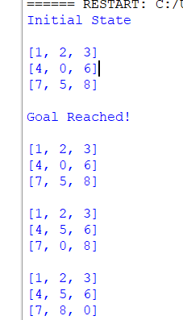

Result-
The 8-Puzzle problem was solved successfully using the Breadth First Search (BFS) algorithm, and the shortest path from the initial state to the goal state was obtained.

